NETFLIX Data Analysis
Data Cleaning

- There are 12 columns and 999+ rows in the data set. Columns “director”, “cast”, and “country” have null values.
- Drop columns with null values as well as column “description”.
- Split the “date_released” column into “date_released_day”, “date_released_month”, and “date_released_year”.
- Removed the duplicates.
- Split column “listed_in” using left-most delimiter and rename as “genre”. Delete the other column.
- In the cleaned data set, there are 10 columns and 999+ rows.

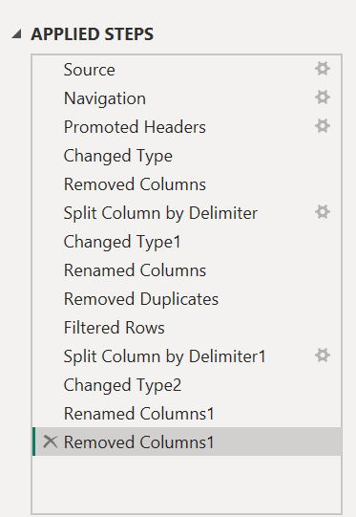
Summary
- There are a total 8804 shows, with 36 unique genres and 18 distinct rating categories.
- A donut chart shows the split between Movies and TV Shows, where Movies make up about 69.6% of all titles.
- Top 10 genres include: Dramas, Comedies, Action & Adventure, Documentaries, etc.
- Bar chart reveals TV-MA and TV-14 as the most frequent ratings
- Content Added Overtime (line chart) shows monthly additions, suggesting relatively consistent releases with a few peaks.
- Content Type Overtime (area chart) displays how both Movies and TV Shows have been added throughout the months, indicating balanced but steady growth.

